Visualize few epochs of raw and preprocessed data Over all data in time domain.

Following are the information:

Sampling rate - 19200

**In data set:**

6th to 17th rows are electrode locations as follows:

Channel_6th – Cz

Channel_7th – CPz

Channel_8th – FCz

Channel_9th – Pz

Channel_10th – FC5

Channel_11th – FC6

Channel_12th – C5

Channel_13th – C6

Channel_14th – CP5

Channel_15th – CP6

Channel_16th – T7

Channel_17th – T8

1st to 5th row is the as follows:

1st row – Reference of time

2nd to 5th row – 2 Trigger rows and right and left stimuli

Out of this - one trigger is not clearly visible in data. So, can work with the other trigger as both are same

Each trigger gives the start of stimuli for right and left ears

I have given antiphase and homo(in)phasic signals in ears. So, need to check that

If both stimuli in right and left are same (homo), the triggers are up (in one direction)

If both stimuli in right and left are opposite (anti), the triggers are down (in other direction)

**In MLR files:**

The trigger and stimuli start

Stimuli longs till 18ms. And total window is 500ms (please confirm it). So, for MLR, response is measured from 18ms to 80/100ms. – Need to visualize and see in all electrode locations.

**In LLR files:**

The trigger and stimuli start

Stimuli longs till 48ms. And total window is 500ms (please confirm it). So, for MLR, response is measured from 48ms to 200/500ms. – Need to visualize and see in all electrode locations.

**Also check the total number of trials and how many inphase and antiphase for each subject**

**I have done as 1000trials in total out which 500 inphase and 500 antiphase. – Need to couble check**

**Matlab command line outpt for number of epochs**

Epochs confirmed

nsub =

4

str =

'*MLR*500*.set'

sub =

1

anylis of subject

sub =

1

filename_anti =

'E:\data\epoched\Sub_2_MLR_500_epoch_anti.set'

filename_in =

'E:\data\epoched\Sub_2_MLR_500_epoch_in.set'

pop_loadset(): loading file E:\data\epoched\Sub_2_MLR_500_epoch_anti.set ...

Reading float file 'E:\data\epoched\Sub_2_MLR_500_epoch_anti.fdt'...

pop_loadset(): loading file E:\data\epoched\Sub_2_MLR_500_epoch_in.set ...

Reading float file 'E:\data\epoched\Sub_2_MLR_500_epoch_in.fdt'...

pop_epoch():500 epochs selected

Epoching...

pop_epoch():500 epochs generated

pop_epoch(): time limits have been adjusted to [-0.020 0.200] to fit data points limits

pop_epoch(): checking epochs for data discontinuity

pop_epoch():500 epochs selected

Epoching...

pop_epoch():500 epochs generated

pop_epoch(): time limits have been adjusted to [-0.020 0.200] to fit data points limits

pop_epoch(): checking epochs for data discontinuity

anylis of subject

sub =

2

filename_anti =

'E:\data\epoched\Sub_3_MLR_500_epoch_anti.set'

filename_in =

'E:\data\epoched\Sub_3_MLR_500_epoch_in.set'

pop_loadset(): loading file E:\data\epoched\Sub_3_MLR_500_epoch_anti.set ...

Reading float file 'E:\data\epoched\Sub_3_MLR_500_epoch_anti.fdt'...

pop_loadset(): loading file E:\data\epoched\Sub_3_MLR_500_epoch_in.set ...

Reading float file 'E:\data\epoched\Sub_3_MLR_500_epoch_in.fdt'...

pop_epoch():500 epochs selected

Epoching...

pop_epoch():500 epochs generated

pop_epoch(): time limits have been adjusted to [-0.020 0.200] to fit data points limits

pop_epoch(): checking epochs for data discontinuity

pop_epoch():500 epochs selected

Epoching...

pop_epoch():500 epochs generated

pop_epoch(): time limits have been adjusted to [-0.020 0.200] to fit data points limits

pop_epoch(): checking epochs for data discontinuity

anylis of subject

sub =

3

filename_anti =

'E:\data\epoched\Sub_4_MLR_500_epoch_anti.set'

filename_in =

'E:\data\epoched\Sub_4_MLR_500_epoch_in.set'

pop_loadset(): loading file E:\data\epoched\Sub_4_MLR_500_epoch_anti.set ...

Reading float file 'E:\data\epoched\Sub_4_MLR_500_epoch_anti.fdt'...

pop_loadset(): loading file E:\data\epoched\Sub_4_MLR_500_epoch_in.set ...

Reading float file 'E:\data\epoched\Sub_4_MLR_500_epoch_in.fdt'...

pop_epoch():500 epochs selected

Epoching...

pop_epoch():500 epochs generated

pop_epoch(): time limits have been adjusted to [-0.020 0.200] to fit data points limits

pop_epoch(): checking epochs for data discontinuity

pop_epoch():500 epochs selected

Epoching...

pop_epoch():500 epochs generated

pop_epoch(): time limits have been adjusted to [-0.020 0.200] to fit data points limits

pop_epoch(): checking epochs for data discontinuity

**Note:-**

Data was capture eyes closed and eyes open – depends on people (Tried to be in silent/rest more relaxed care has taken not to fall asleep)

Please check any significant power line noise in raw data both LLR and MLR data.

Please check to see whether 50hz noise is present in EEG data of any subject so far

Please update me what u have seen from the plotting. Like how many epochs in total, what timing and all other details – Double check with information shared.

Also u can see the filters both highpass and the notch and data is downsampled to 2048hz

Beforepre processin sub 2 MLR anit phase

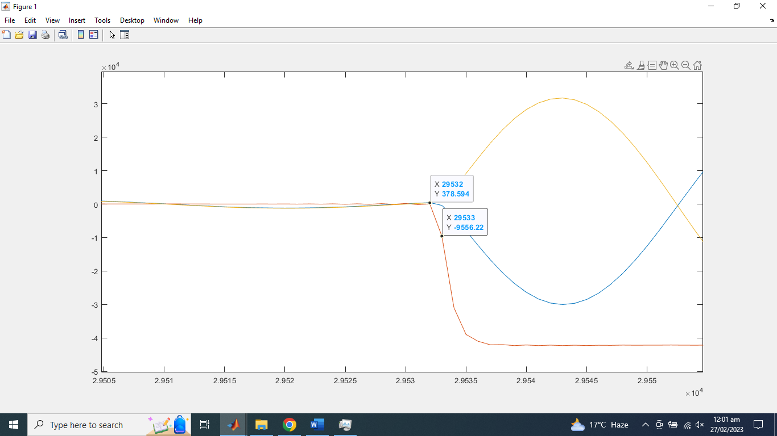

After preprocessing processing of same subject

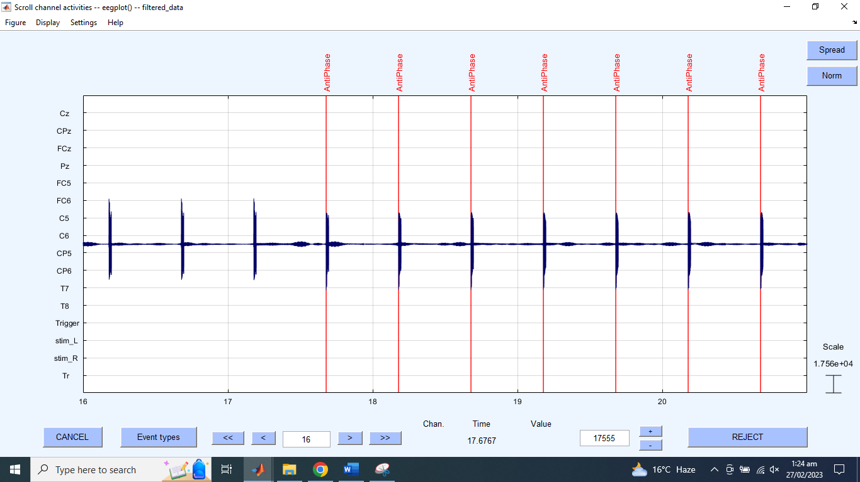

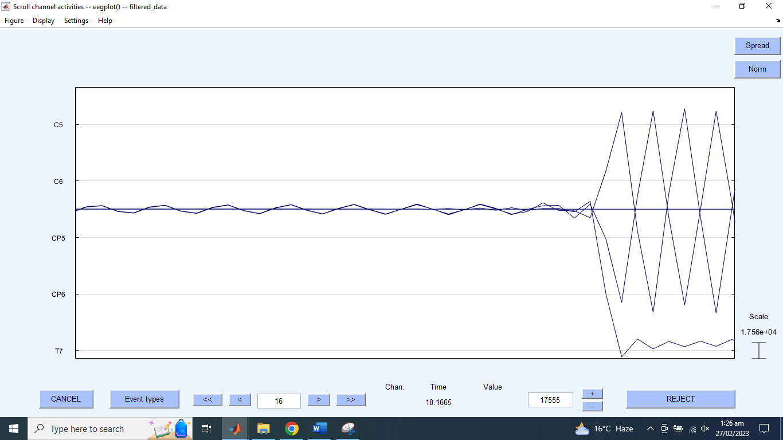

Subject 2 LLR anti-phase

Before preprocessing

After preprocesing

